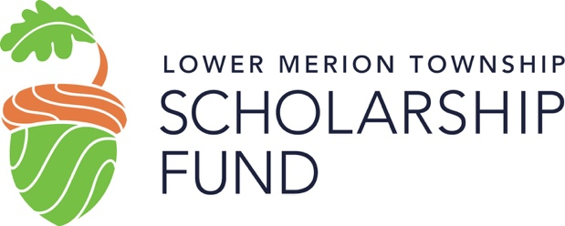
PO Box 346, Ardmore PA, 19003
Tel: 610.645.1893
Email: lmtsf@lmsd.org

November 2023

To: Renewal Scholarship Applicants

From: The Lower Merion Township Scholarship Fund

Subject: Instructions for RENEWAL Application for 2024-2025 Academic Year

ELIGIBILITY: To be eligible to receive an award from the Scholarship Fund, you must have graduated from or be a graduating senior of Harriton or Lower Merion High Schools, have been a resident student in the Lower Merion School District for four years, and remain a full-time undergraduate student for the duration of the grant. Applicants must also demonstrate a financial need based on financial information and documentation submitted with his/her application, in order to be considered for a grant. (Need is determined by an independent financial consultant.) Grants are not automatically renewed annually. Applicants may reapply for a grant renewal, for a maximum of eight semesters.

PLEASE READ ALL INSTRUCTIONS CAREFULLY. All forms must be completed and returned to the LMTSF office by February 23, 2024. Due to an ever-increasing number of applicants, we must hold fast to our February 23rd deadline. If you have questions concerning our instructions, please contact LMTSF administrator, Mary Donoghue, at donoghm@lmsd.org or 610-645-1893. If you do not follow these directions, we will not be able to process your application.

INSTRUCTIONS FOR COMPLETING
Lower Merion Township Scholarship Fund
NEW APPLICATION

- The LMTSF RENEWAL Application forms and instructions must be downloaded from the LMTSF website, www.lmtsf.org, under the “Apply” tab. Applications must be completed using a computer. Handwritten applications will not be accepted. Please refer to the checklist provided to ensure completion:

- Completed Renewal Application Form for 2024-25 Academic year.

- Family Finance Summary form and 2022 tax documents: Family Finance Summary form must be downloaded from the LMTSF website, www.lmtsf.org, under the “Apply” tab. (Form must be completed using a computer.) Please also provide copy of BOTH parent(s)’ 2022 Federal Tax Return (with supporting Schedules and W-2’s, if applicable).

*If biological or adoptive parents are divorced, separated, or are no longer living in the same household, a 2022 Federal Tax Return must also be included for the noncustodial parent. Please also include child support/alimony for the non-custodial parent. If for any reason it cannot be provided, please include a letter stating the reason and circumstances with your application.

All financial documentation is kept confidential and provided ONLY to the outside financial consultant in order to determine financial need.

- Renewal Applicants have the option of submitting applications in one of two ways:

- Place all printed material in a large envelope and send via U.S. Postal Service to:
Lower Merion Township Scholarship Fund
PO Box 346
Ardmore, PA 19003
Attn: Mary Donoghue

- Send all materials electronically. Please save your electronic application as “last name-first name-RA-24-25” and your Family Financial Summary form as, “last name-first name-AFFP-24-25”. Please remember if you are submitting your application via email, you MUST still sign your application. Please email all materials to donoghm@lmsd.org and use “2024-25 RENEWAL application: YOUR NAME” in the subject line.**

- You will receive an email confirmation once application material is received. Please be aware that it may take a few days for materials to reach the LMTSF office and be processed.

Deadline for all applications is Friday, February 23, 2024.

**Helpful Tip: If you need to scan copies of financial documents, use a scanning app from your mobile phone (such as Adobe Scan) so documents scan as PDF’s.

