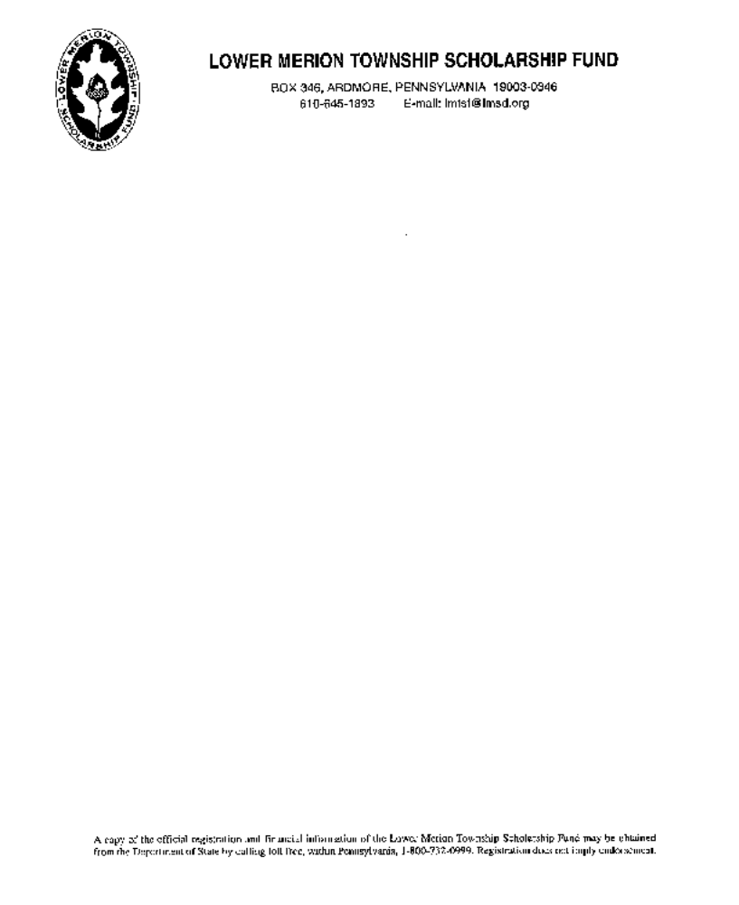

October 2017

To: All Renewing Applicants

From: The Lower Merion Township Scholarship Fund

Subject: Instructions for Application for 2018-2019 Academic Year

All forms and instructions needed to re-apply for a scholarship grant can be downloaded from this site.

1. Instructions for completing 2018-19 Renewal Application
2. Renewal Application Form
3. Student Family Finance Summary Form

ELIGIBILITY: To be eligible to receive an award from the Scholarship Fund, you must have graduated from or be a graduating senior of Harriton or Lower Merion High Schools, have been a resident student in the Lower Merion School District for four years, and remain a full-time undergraduate student for the duration of the grant. Applicants must also demonstrate a financial need based on financial information and documentation submitted with his/her application, in order to be considered for a grant. (Need is determined by an independent financial consultant.) Grants are not automatically renewed annually. Applicants may reapply for a grant renewal for a maximum of eight semesters.

PLEASE READ ALL INSTRUCTIONS CAREFULLY. All forms must be completed and
returned to the LMTSF office by February 23, 2018. Due to an ever-increasing number of applicants,
we must hold fast to our February 23rd deadline. If you have questions concerning our instructions,
please contact the LMTSF Administrator, Mary Donoghue at donoghm@lmsd.org or 610-645-1893.
If you do not follow these directions, we will not be able to process your application.

.

INSTRUCTIONS FOR COMPLETING RENEWAL APPLICATION

- The Renewal Application can be found on our website, www.lmtsf.org, by following the “Apply” link on the Homepage. Once on the “Apply” page, be sure to open the RENEWAL Application. Please complete it using your computer (handwriting will not be accepted). Once completed, save it as “Last Name-First Name-RA-18-19” to your desktop to be sent electronically, or printed out to mail with supporting documentation.

2. Enclose 2016 Federal Tax Return(s) and W-2’s for both parents (which will be forwarded to our Financial Aid Consultant) with your application. If an IRS form was not filed last year, a letter of explanation must be sent with the application.

3. Applicant must submit the Applicant’s Family Financial Summary. The form can be found on our website, www.lmtsf.org, on the “Apply” Page, under “For All Applicants.” Please complete the form using your computer (handwriting will not be accepted), print it out and include it with your parents’ 2016 Federal Tax Return(s) and W-2’s.

If biological or adoptive parents are divorced, separated, or are no longer living in the same household, a 2016 Federal Tax Return must be included for the noncustodial parent. If for any reason it cannot be provided, please include a letter stating the reason and circumstances with your application.

4. When submitting your LMTSF Renewal grant application, please check that you have
sent the following:
- Completed Renewal Application 2018-19 Form
- University Fall 2017 Transcripts
- Family Financial Summary form and supporting tax documents

5. The signed 2018-19 Application, with supporting documentation, can be submitted electronically to donoghm@lmsd.org, by fax (610-896-2017), or by mail to:

Lower Merion Township Scholarship Fund
PO Box 346
Ardmore, PA 19003

(If submitting your application electronically, please send a scanned (or screenshot) of the signature page of your application.)

If you do not receive an acknowledgement of receipt by e-mail within 2 weeks of submission, contact the Scholarship Office at donoghm@lmsd.org or 610-645-1893, to verify your application was received.

Application Deadline is February 23, 2018.

